Experiment No. 4: 7-Segment Display Control Using Arduino

## Aim

To write code to control a 7-segment display using an Arduino.

## Theory

A 7-segment display is an array of LEDs arranged in a figure-eight pattern to display numbers (0-9) and some letters. Each segment (labeled A to G) can be turned on or off to form desired digits.

Arduino provides programmable digital output control to manipulate each segment of the display.

## Materials Required

- Arduino Uno board  
- 7-Segment Display (Common Cathode)  
- 220-ohm resistors  
- Breadboard  
- Jumper wires

## Procedure

1. Identify segment pins A to G on the 7-segment display.  
2. Connect these pins to Arduino pins 2 to 8.  
3. Connect the common cathode to GND via a 220-ohm resistor.

## Code

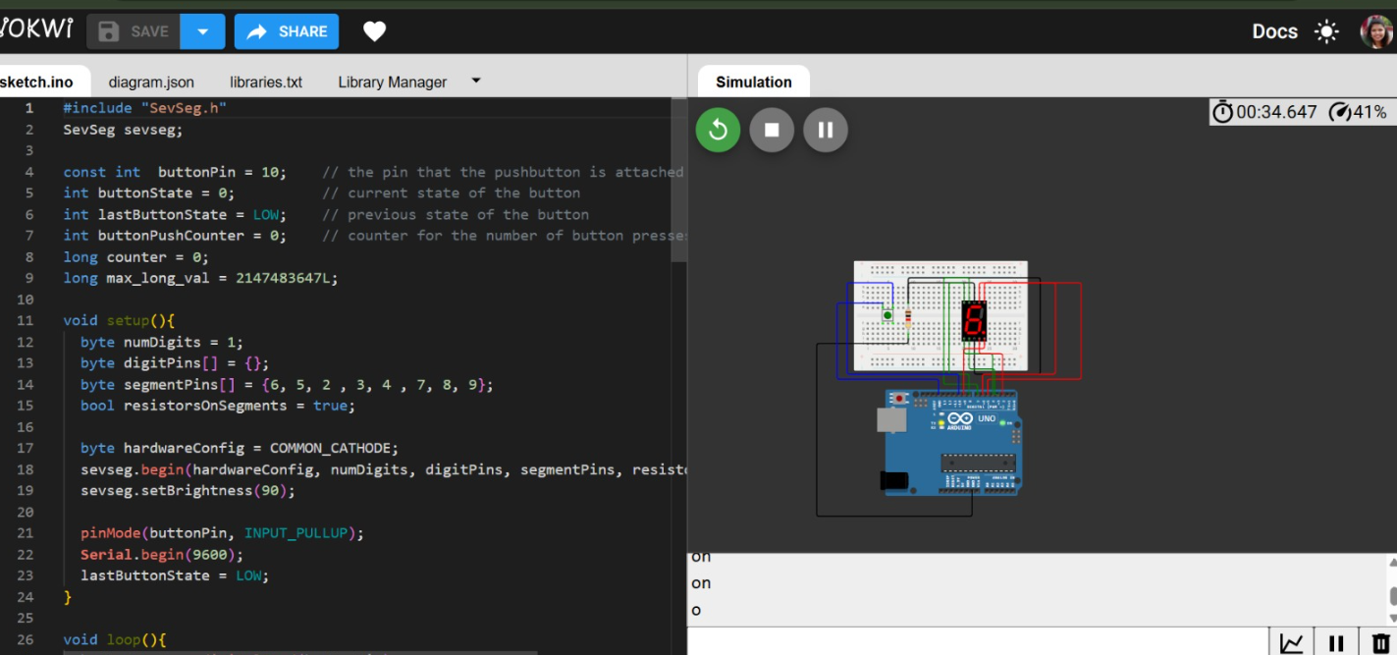

## Working

The Arduino lights up appropriate segments to show digits 0 to 9 sequentially. Each digit appears for 2 seconds, demonstrating display control using segment patterns.

## Conclusion

This experiment successfully demonstrated control of a 7-segment display using Arduino. Students learned to map segments and write logic to display numbers, reinforcing digital output and pattern control.